Nuclear Engineering Projects

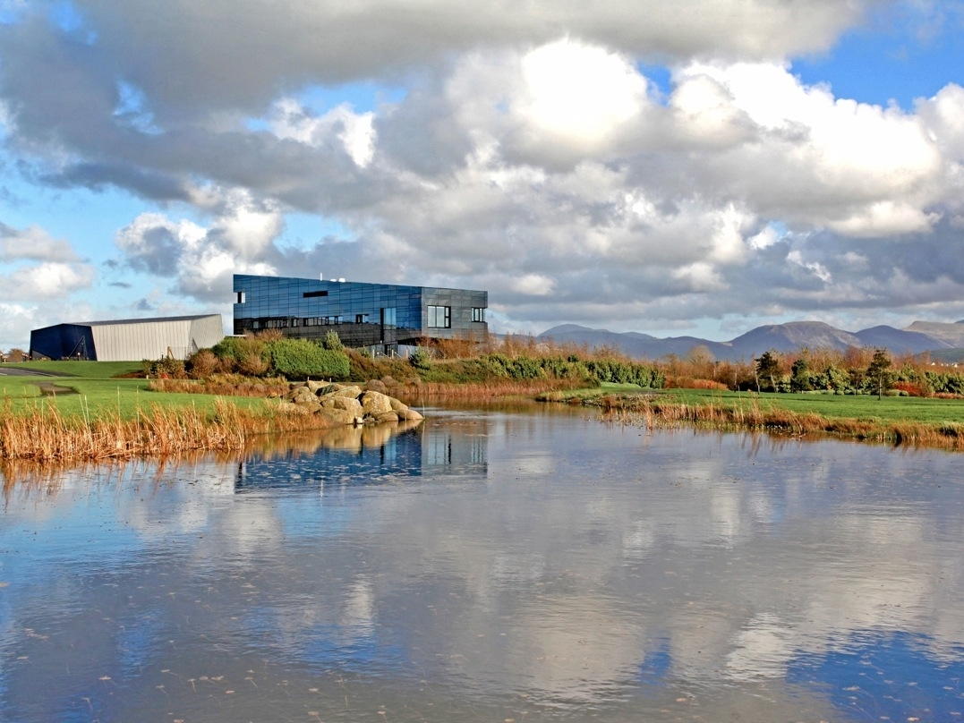

The University of Manchester

  - July 2016

School of Electrical and Electronic Engineering
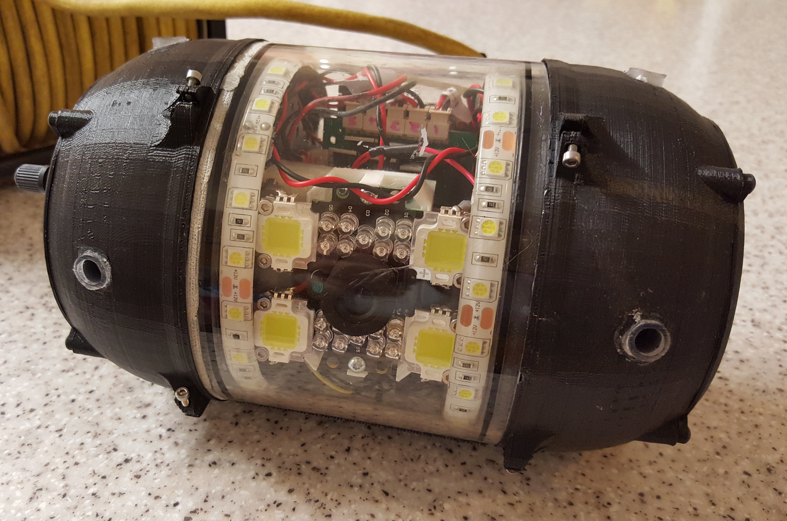 | AVEXIS 150 – MiniROV Duration: Sep 2014 – Jun 2017  AVEXIS is a small underwater vehicle that has been designed to survey and monitor challenging environments, particularly the legacy ponds and silos at Sellafield. This project aims to demonstrate the use of AVEXIS on the Sellafield site in 2016.  Personnel: Arron Griffiths (PDRA based at Workington), Simon Watson, Barry Lennox.  Partner: Xavier Poteau (Sellafield Ltd), Mark Telford (Forth Ltd)  Funder: Sellafield, NNL, UoM
Debris Activity Measurement for Submerged Environments and Locations (DAMSEL)  Duration: Dec 2015 – Feb 2018  Design of a ROV able to fit through a 100 mm access port to deploy neutron and gamma detectors in to the flooded reactors at the Fukushima site to locate and analyse the melted fuel.  Personnel: Dale Potts (PDRA based at Workington), Barry Lennox, Simon Watson  Partner: Lancaster University, JAEA, NMRI (Japan)  Funder: EPSRC |  |  | 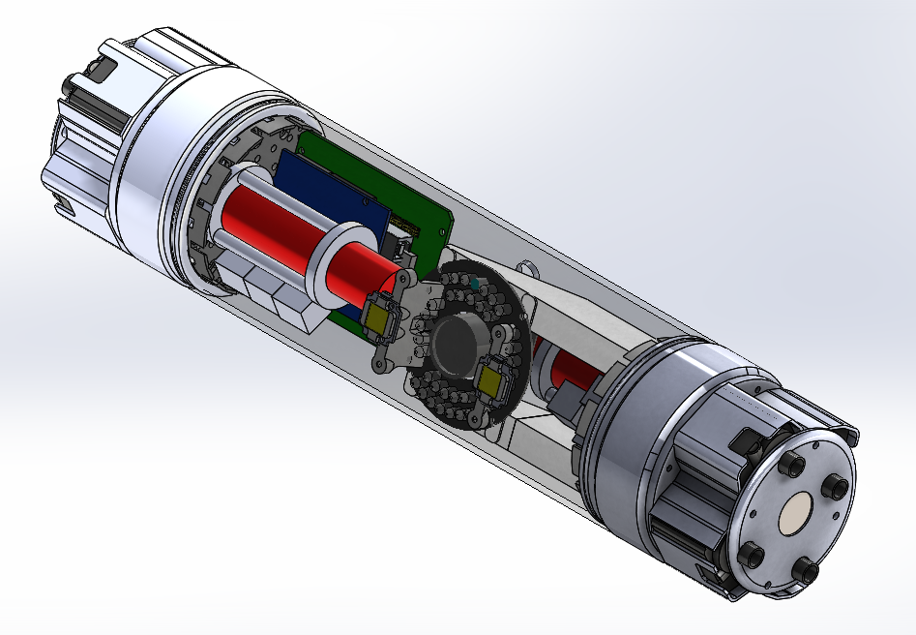
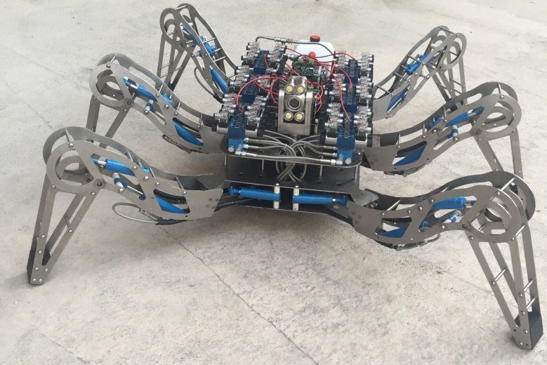 |  | LATRO Duration: Aug 2015 – Aug 2018  Latro is a robotic spider that can be used in the monitoring and decommissioning of both dry and wet nuclear storage facilities. The robot is designed to cut, sort and retrieve material from storage facilities. It employs six hydraulically actuated legs for motion and two arms for carrying large grippers and cutters (weighing up to 20 kg).  Personnel: Farshad Arvin (PDRA based at Forth Eng in Flimby, Cumbria), Barry Lennox, Simon Watson  Partner: Mark Telford (Forth Engineering), Innovate UK (KTP project)  Funder: Forth and Innovate UK
Underwater Positioning and Communications  Duration: Sept 2016 – July 2019  Design of underwater positioning and communication systems necessary to enable the AVEXIS and other ROVs to autonomously manoeuvre around constrained submerged areas, such as the legacy ponds and silos.  Personnel: TBA (PDRA based at Forth Eng in Flimby, Cumbria), Simon Watson, Barry Lennox  Partner: Mark Telford (Forth Engineering), Innovate UK (KTP project)  Funder: Forth and Innovate UK |  |  | 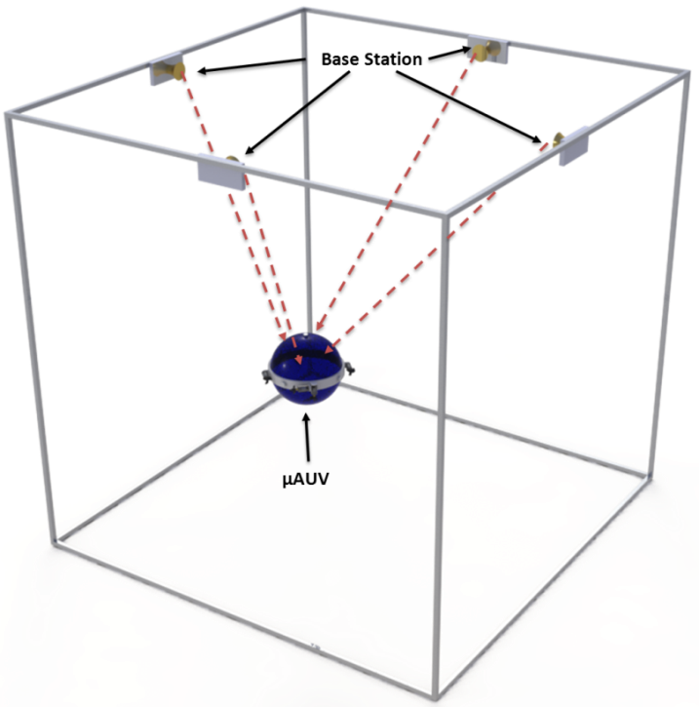
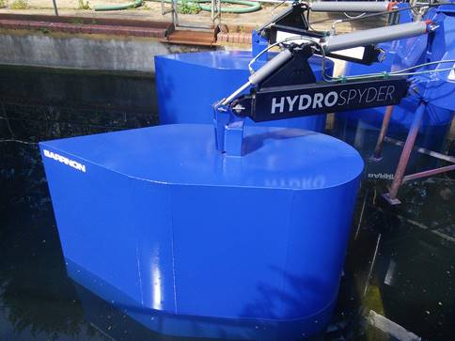 |  | HydroSpider Duration: Jan 2016 – Oct 2018  HydroSpider is a floating crane that is being designed to provide alternative lifting capabilities in the legacy ponds on the Sellafield site as well as elsewhere. This KTP project is supporting the development of the equipment.  Personnel:, Shuai Wang (PDRA based at Appleby, Cumbria), Will Heath, Andy Weightman, Barry Lennox  Partner: Andy Barr (Barrnon)  Funder: Barrnon, Innovate UK (KTP project)
MIRRAX - Mini Robots for Restricted Access Exploration  Duration: Nov 2015 – Mar 2017  MIRRAX is a reconfigurable mobile robot platform that is being designed for deployment in areas on the Sellafield site with restricted access. Using omnidirectional wheels, the MIRRAX can reconfigure its shape, allowing entry through a 6 inch access port while being large enough to climb stairs. Payloads such as HD cameras, LIDARs and radiation sensors are being integrated in to the robot.  Personnel: Horatio Martin (PDRA based at Workington), Simon Watson, Barry Lennox  Partner: Xavier Poteau (Sellafield Ltd)  Funder: Sellafield, EPSRC, UoM |  |  | 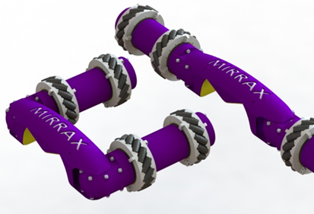
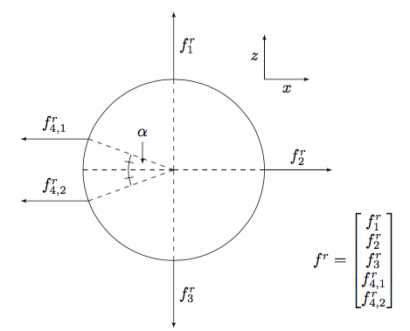 |  | Control System Design Duration: May 2016 – Apr 2017  Modelling, analysis and control system development for the AVEXIS ROVs. This project is investigating the development of control system that will enable automated depth in the AVEXIS vehicles and is also examining the feasibility of reducing the size of the ROV so that it can be deployed through 60 mm access ports.  Personnel:, MihalisTsiakkas (PDRA based at DCF), Simon Watson, Barry Lennox  Funder: UoM
Remote Operations Engineer Duration: Sept 2015 – Aug 2018  Arron Griffiths is working on a number of robotics projects with Sellafield, NNL and UoM. These include working on Laser Snake 2, developing a radiation monitoring robot and building a prototype of a small scale AVEXIS robot.  Personnel: Arron Griffith (PDRA based at Workington), Barry Lennox, Simon Watson  Partner: Tom Robinson (Sellafield Ltd), Ed Butcher (NNL)  Funder: Sellafield, NNL, EPSRC, UoM |  |  | 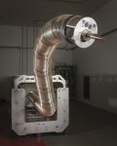

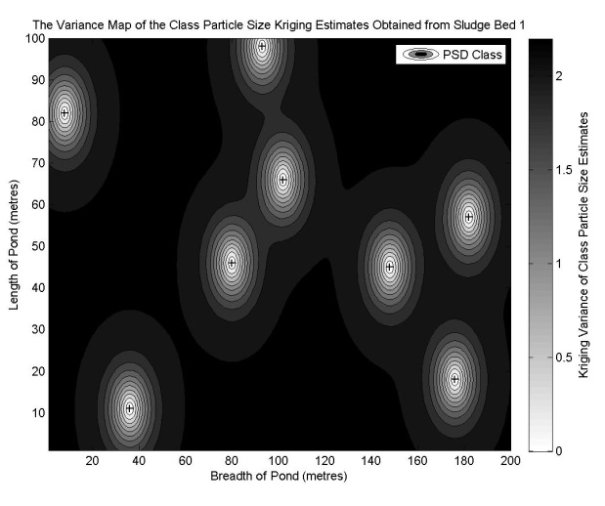 | In Situ Monitoring Of The Legacy Ponds And Silos At Sellafield  Duration: Sep 2015 – Feb 2019  This research is identifying experimental factors that influence the quality of samples and measurements that are taken of the sludge within the legacy ponds on the Sellafield site. By understanding the impact that variability, sludge sampling equipment and measuring system has on results, the quality of the data and the types of sampling regime required to accurately characterise the ponds can be obtained. The research is focusing on the in-situ and ex-situ measurement of particle size distribution (PSD) as an indicator of the physical properties of sludge.  Personnel: Olu Ayoola (PhD based at DCF), Barry Lennox, Simon Watsons  Sponsor/Partner: Geoff Randall (Sellafield Ltd)

